

## 

Teacher:  
**“Sir Mansoor”**

Students:

* HAFIZ SYED MAAZ Student ID:1412993
* SYED MUHAMMAD SAAD Student ID:1410289
* ABDUL REHMAN SIDDIQUI Student ID:1410804
* TAUQEER AHMED KHAN Student ID:1411388

**Batch Code: PR2-202208B1**

TABLE OF CONTENT

**Table of Content**-----------------------------------------------------------------02

**Project Certification** ---------------------------------------------------------- 03

**Acknowledgement** ------------------------------------------------------------ 04

**Objective** --------------------------------------------------------------------------05

**Requirement** --------------------------------------------------------------------- 06

**Hardware and Software**-------------------------------------------------------07

**Project Duration** ----------------------------------------------------------------08

**Task Sheet**------------------------------------------------------------------------09

**Screen Shot**----------------------------------------------------------------------10

PROJECT CERTIFICATION

***This is to certify that this project entitled “Tangoline”is submitted in partial fulfillment of the ACCP Prime 2.0 Semester-1 e.project done by following candiates.***

* HAFIZ SYED MAAZ
* SYED MUHAMMAD SAAD
* ABDUL REHMAN SIDDIQUI
* TAUQEER AHMED KHAN





ACKNOWLEDGMENT

We are very thankful to dear Almighty Allah by his grace we are able to complete this task.

We would like to acknowledge all those who helped and guide us all the way to finish this task.

Especially our great teacher “Sir Mansoor”without him we would not have done it.

Also, we would like to thanks all the staff

members of Aptech to work with them on this project and also providing us their support.

We would also like to express our sincere gratitude to i-project team from Aptech head office and our project guide at the organization for their valuable guidance and support for completion of this project.



OBJECTIVE

The Objective of this program is to give a sample project to work on real life

projects. These applications help you build a larger more robust application.

The objective is not to teach you JavaScript/Dreamweaver but to provide you with a

real life scenario and help you create basic applications using the tools.

You can revise the chapters before you start with the project.

This project is meant for students who have completed the module of

Dreamweaver. These programs should be done in the Lab sessions with assistance

of the faculty if required.

It is very essential that a student has a clear understanding of the subject. Students

should go through the project and solve the assignments as per requirements given.

Kindly get back to eProjects Team in case of any doubts regarding the application or

its objectives.

REQUIREMENTS

1) Home Page should contain logo of the site with proper sections and details of games and consoles with suitable images.

2) The site should display a menu which will contain the options for brief

introduction about the various games and console available, location of the

shop and any other information if required.

3) The information should be categorized according to the brand names of the

products like if a User wants to see only “SONY” products or any other

companies products then he/she can click on a Link/button/menu etc and can

see only that Brand products.

4) Another category option for Consoles and Video Games should be created and accordingly the products should be listed.

5) When a user selects any particular brand, a list of products for that brand will be displayed

6) A brief summary of features of individual products should be displayed on the Web Page along with the product but detailed Features should be stored in Individual Word documents which can be downloaded or viewed by the User who wishes to see the same.

7) The user should also be able to compare the various products of different as well as similar brands.

8) There should be a “Contact Us” page which will have the Address of the

Company which is as follows and the mail address which when clicked will

invoke the local mail client from where they can send an email.



HARDWARE / SOFTWARE REQUIREMENTS

Hardware:

A minimum computer system that will help you access all the tools in the courses is a Pentium 166 or better



64 Megabytes of RAM or better



Software:

* + Notepad/HTML editor
* Dreamweaver
* IE 5.0/Netscape 6.0

PROJECT DURATION



Analysis: 2 Days

Design: 8 Days

Development: 8 Days

Testing: 5 Days

Documentation: 1 Day

USER GUIDE:

Home Page: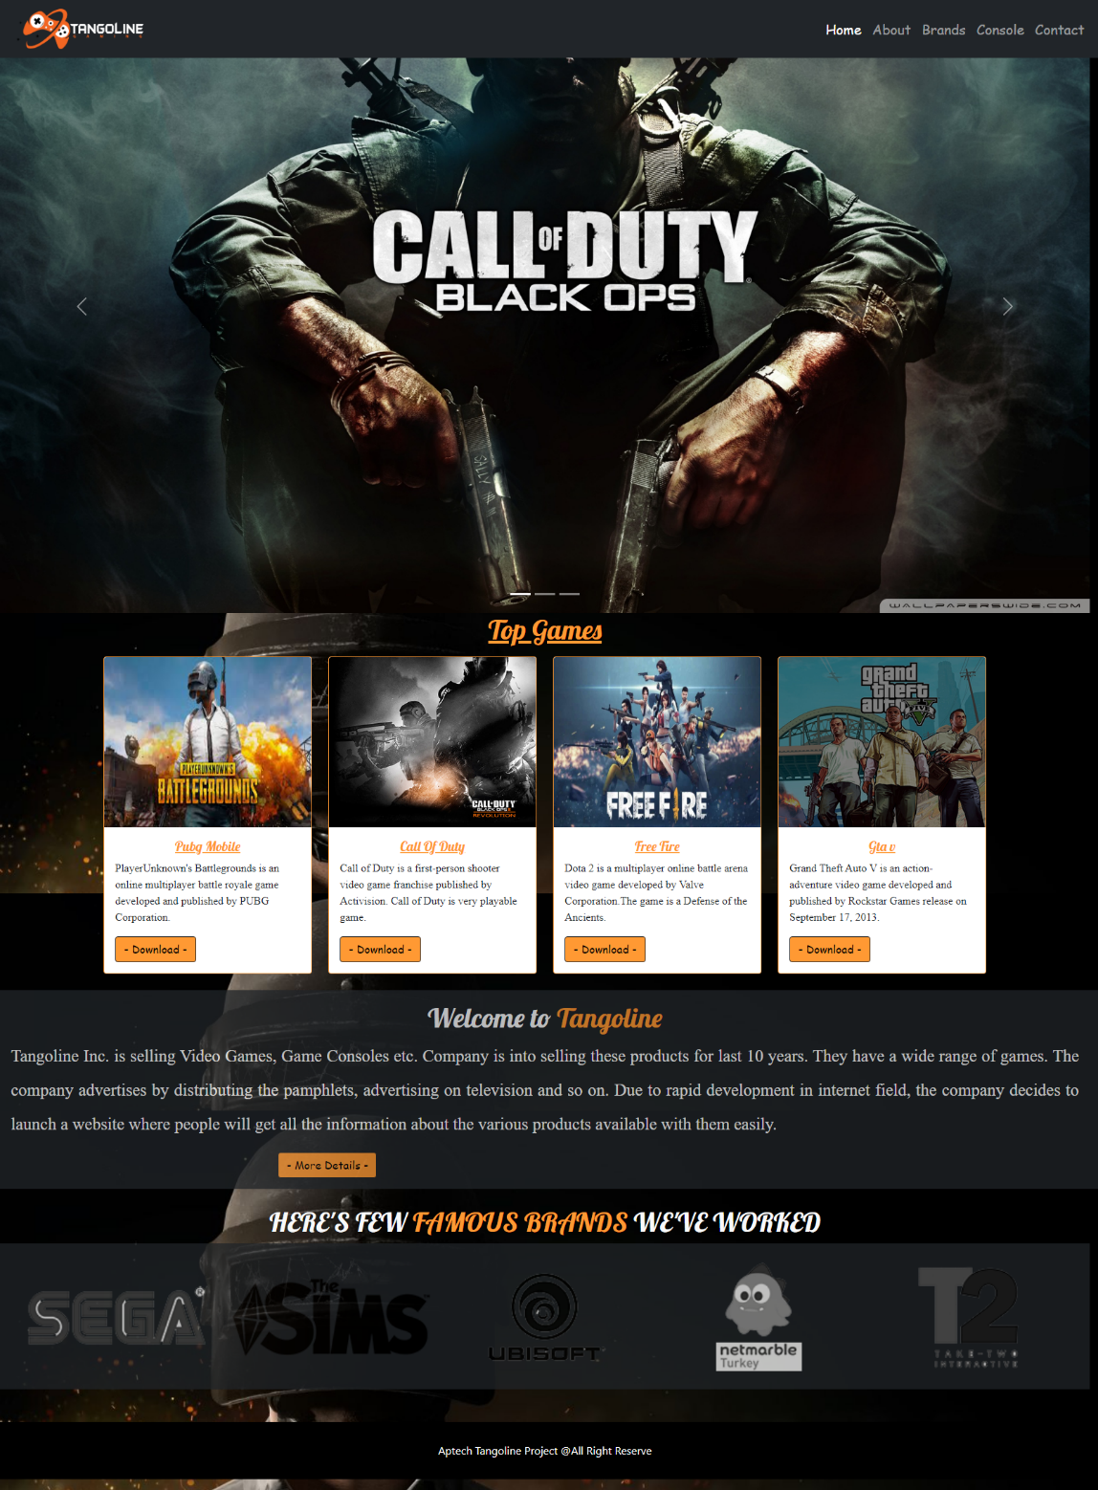

About:

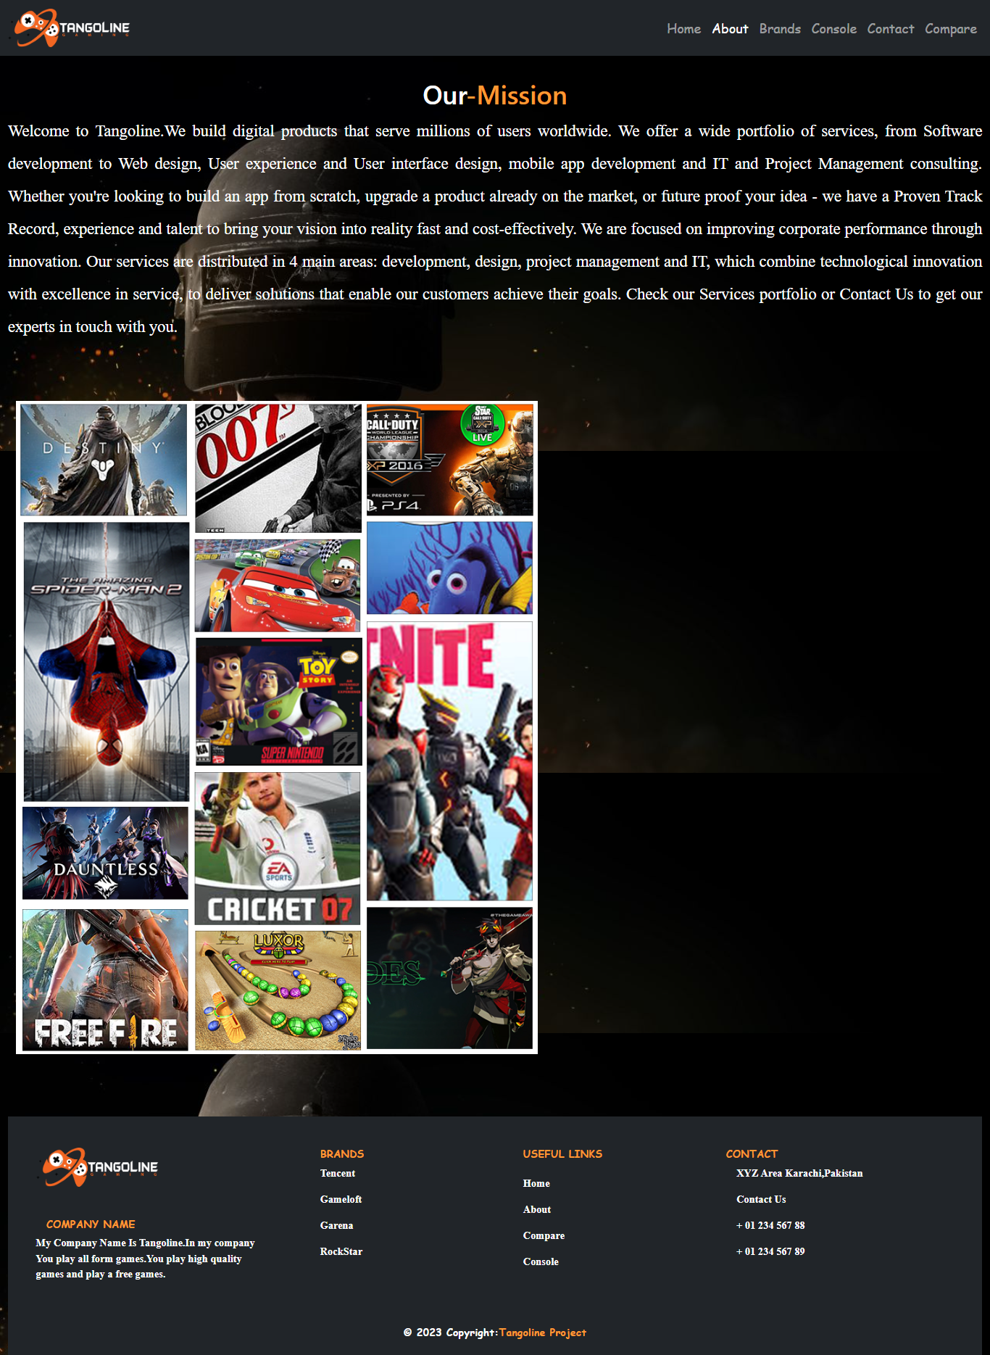



Brands:

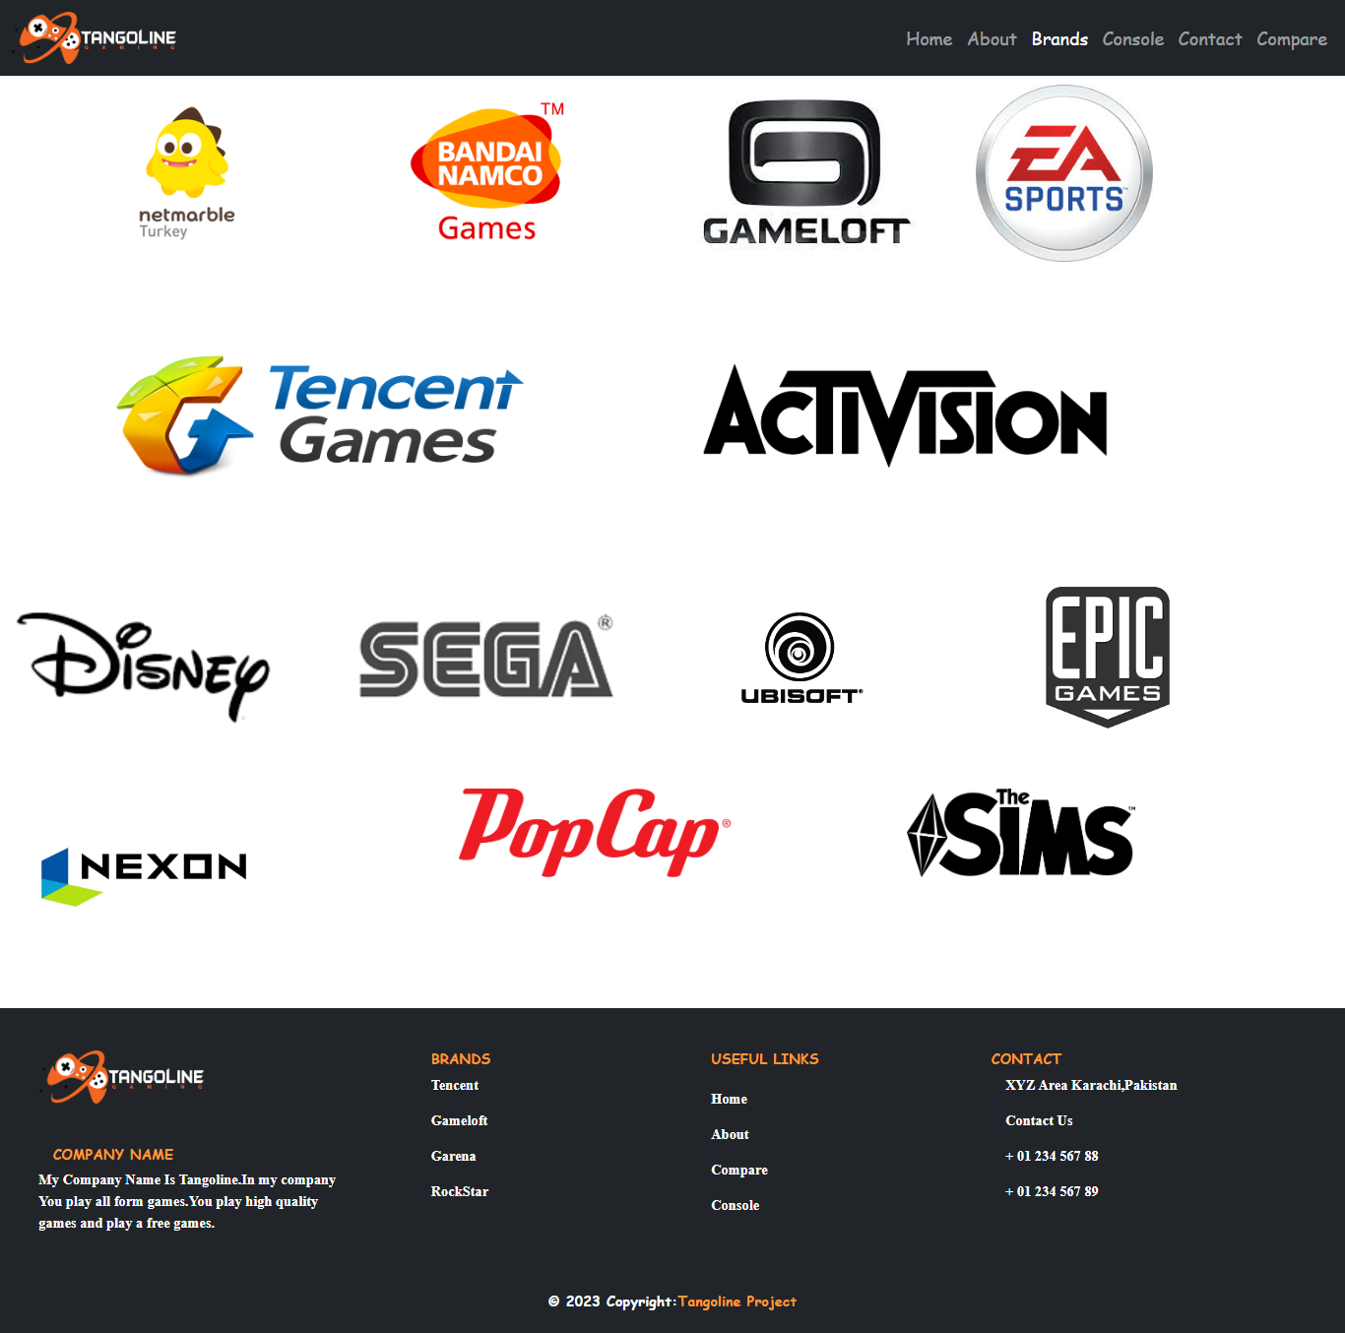



Console:

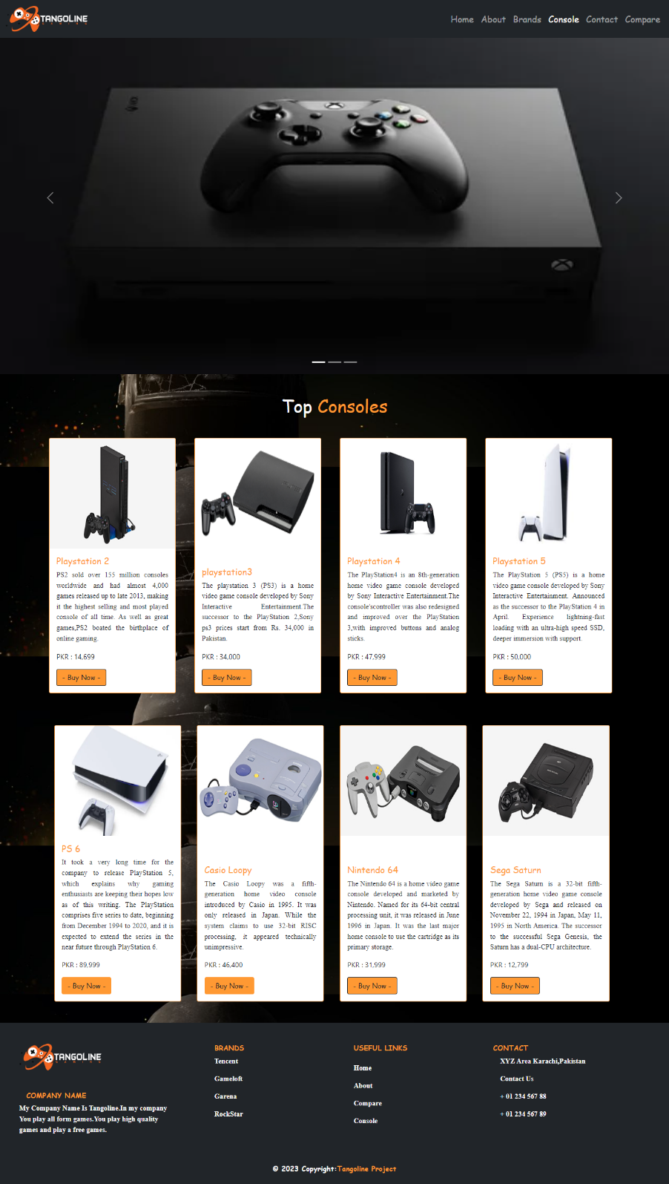

Contact us:

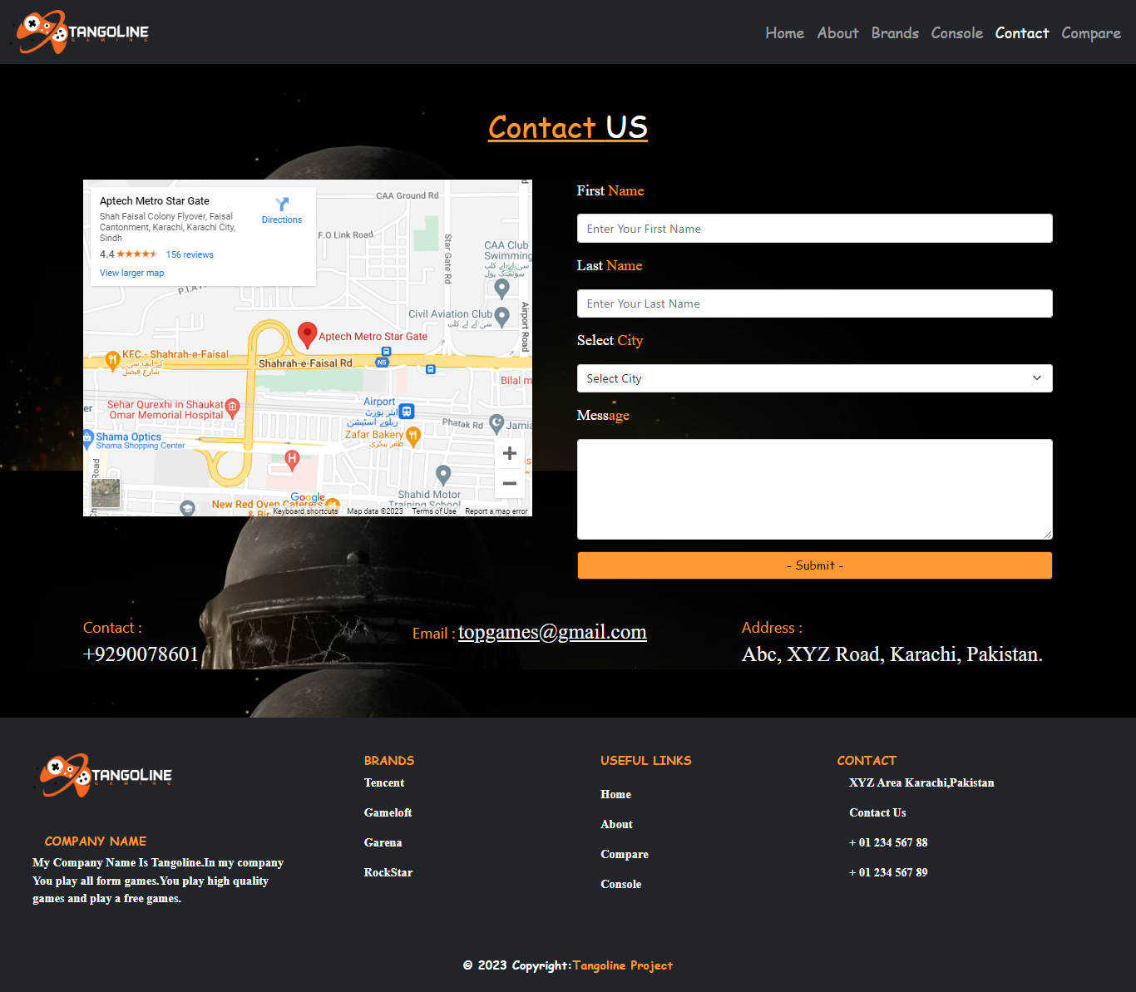



Compare: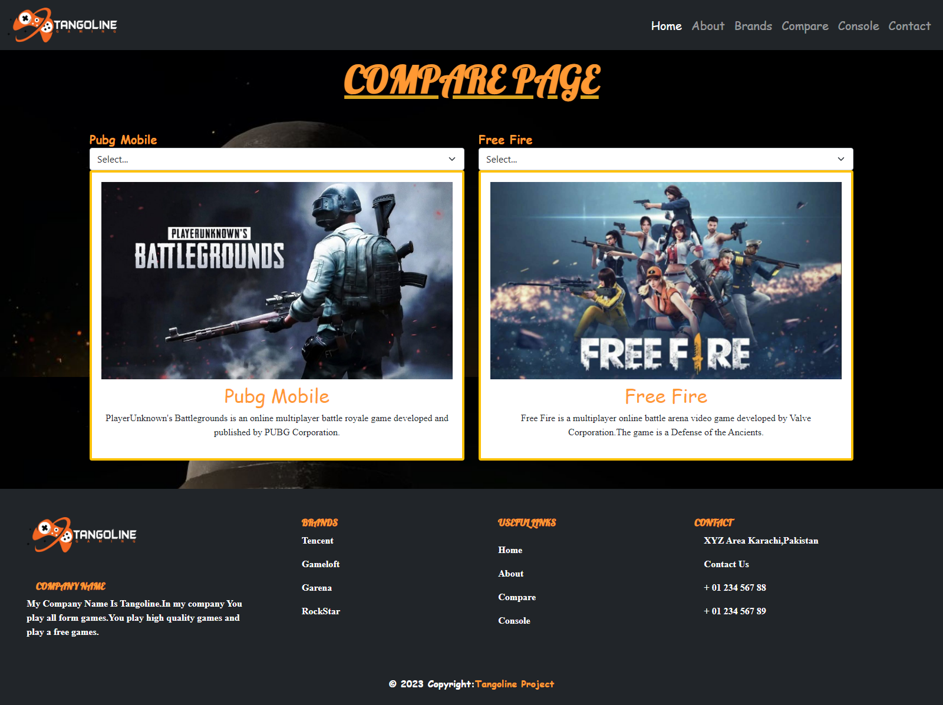



|  |  |  |  |  |
| --- | --- | --- | --- | --- |
| Project Ref. No. | | Project Title | Date of Preparation of Activity Plan | |
| S.No. | Ta | **Handicrafts** | Actual Days | Status |
| 1 | Analysis | 1 | OK |
| 2 | Design | 4 | OK |
| 3 | Development | 7 | OK |
| 4 | Testing | 1 | OK |
| 5 | Documentation | 1 | OK |

**Task Sheet**